Christopher Columbus and John Smith

From the online supplemental material to the Norton Anthology
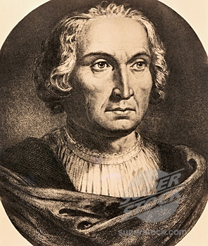 Columbus Questions for Discussion

We encounter Christopher Columbus through the effects of time, of translation, of cultural difference between our own historical moment and his. In thinking about the letters included in NAAL as part of the American literary heritage, we also need to consider the Columbus myth: its golden age in the early nineteenth century, its continuing presence, and the vigorous reaction against it. In the early years of the American republic, as the new nation sought out founder-heroes, writers such as Joel Barlow and Washington Irving represented Columbus as an Aeneas for the New World, or even as its Moses. Irving closes his Life and Voyages of Christopher Columbus (1828) this way:

What visions of glory would have broken upon his mind could he have known that he had indeed discovered a new continent, equal to the whole of the Old World in magnitude, and separated by two vast oceans from all the earth hitherto known by civilized man! And how would his magnanimous spirit have been consoled, amid the afflictions of age and the cares of penury, the neglect of a fickle public and the injustice of an ungrateful king, could he have anticipated the splendid empires which were to spread over the beautiful world he had discovered; and the nations, and tongues, and languages which were to fill its lands with his renown, and revere and bless his name to the latest posterity.

A generation earlier, Barlow's The Vision of Columbus (1787) -- an epic-style poem rarely read today -- imagined the explorer as blessed, at the end of his life, with a vision of an American promised-land future. Throughout the Western Hemisphere, cities, universities, rivers, and a country were named for him -- and in pious and prophetic robes, he is memorialized with countless statues and courthouse frescoes.

1. Compare Columbus’s descriptions of the islands’ plants, natural features, and native inhabitants in the first and second letters featured in The Norton Anthology of American Literature. While the first letter is filled with the language of wonder and insists on the fertility and diversity of natural productions, the second letter is considerably less sanguine. Rather, Columbus seems preoccupied by the political strife created by the fractious colonists and by his resentment that his explorations have not generated great personal wealth. What political project was each letter intended to serve. Why might Columbus insist that “Españolais a marvel” in the first letter, and then portray it as an “exhausted,” unhealthy place populated by “cruel savages” in his later account?

2. In his “Letter to Luis de Santangel,” Columbus declares that he has “taken possession” of the islands for “their highnesses” Ferdinand and Isabella of Spain. What procedures does Columbus follow in order to take possession? What kind of attitude toward the native inhabitants’ rights underlies the ritual of possession that Columbus employed?

3. Columbus is clearly aware that the lands he “discovered” already have native Indian names. In his “Letter to Luis de Santangel,” for example, he explains that the Arawak Indians call their island “Guanahani.” Yet Columbus seems to have no reluctance about renaming the islands he visits, sometimes for religious reasons (San Salvador) and sometimes after Spanish royalty (Fernandina). Why does he feel justified in renaming the
islands? What might he have hoped to accomplish in bestowing these Spanish names? How might his act of discovering and naming relate to the biblical account of Adam naming objects in Eden in the Book of Genesis?

4. Columbus Day (the second Monday in October) has been celebrated as a national holiday since the early twentieth century. What are Americans supposed to be celebrating on that day? Should Americans continue to observe Columbus Day? Does the fact that the holiday was first instituted by Italian immigrant groups seeking to solidify their position in American society affect your assessment of its significance?

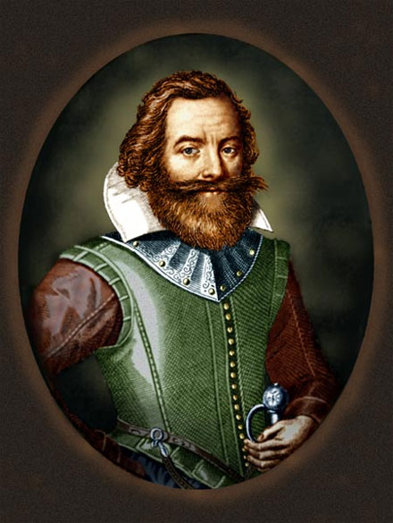 John Smith Questions for Discussion

Even by Americans who have never read his words, Smith is remembered as a soldier, an adventurer, an action hero. Smith did not write his account from meticulous and extensive notes and journals, but years after from his recollections, and perhaps also from his sense of theater. Compared to that of Columbus, Smith's literary style is lush and self-conscious.

1. Some literary critics and historians have argued that Smith’s inclusion of Pocahontas in the later narrative (it is not in his original accounts) represents an effort to capitalize on her status as a celebrity in England. After she had converted to Christianity, married John Rolfe, traveled to England, and been presented at Court, Pocahontas was revered as an assimilated and fully Anglicized Native American—the ideal colonial subject. Thus, Smith’s anxiousness to assert a significant relationship with her might be just one more example of his commitment to self-promotion. What other reasons Smith might have had for revising his account in this way. What assumptions about Indian-European relations, gender (Feminist reading), and politics underwrite this story? Why has the story achieved archetypal status? What kind of fantasy about American power does it represent?

2. What problems does Smith have with the other English colonists in the Virginia Company? How does he represent his own leadership abilities? What role do class (Marxist reading) and nobility play in his leadership and in the colony in general?

3. One of the models of the ideal conqueror for Spanish and British colonists alike was the Roman emperor Julius Caesar, who wrote his autobiographical commentaries The Gallic War in the third person and referred to himself as “he.” What impact does Smith’s choice of a third-person narrator have on The General History?

4. Why does Smith interrupt his narrative in The General History with passages of translated classical verse? What general rhetorical purpose do classical allusions play in the narrative?

5. Since John Smith, a hundred years later, became a legendary hero like Columbus, compare the tone and content of Smith's What Happened Till the First Supply to Columbus's letters. In what ways can we connect these texts to the American landscape and to the American mythology of individuality and hard work?

