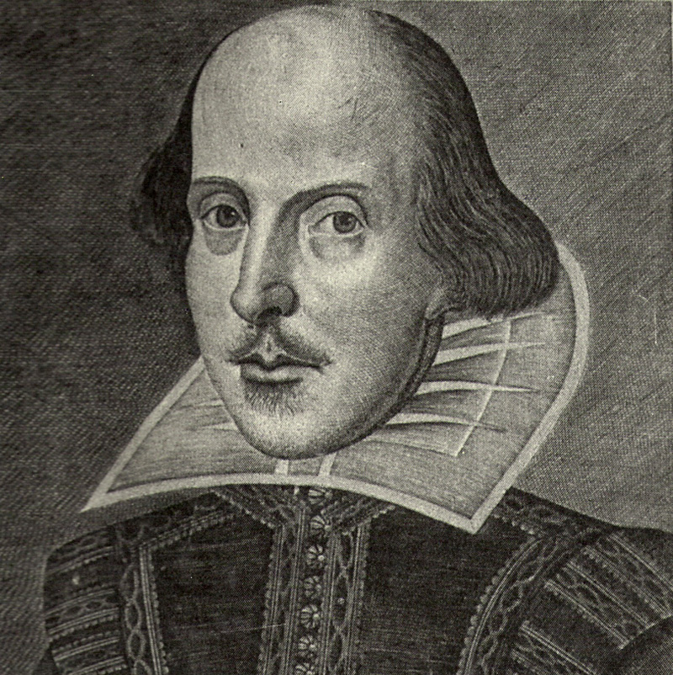 ELIT 17 Introduction to Shakespeare
Will Power! The plot thickens around religion, sex, royalty, and mystery in the great works of Shakespeare

Instructor: Julie Pesano
Phone: (408) 864-8653
E-mail: pesanojulie@fhda.edu or jpesano@gmail.com (gmail a bit more reliable)
Web Page: http://deanza.edu/faculty/pesanojulie/ELIT-17.html
Class Time/ Location: Monday/Wednesday 12:30-2:20 MLC 112
Office Location: F61L (Near the Turtle Sculpture)
Office Hours: Monday/Wednesday – 2:30-3:45 (please let me know if you plan to stop by)
Or By Appointment

Required Texts: William Shakespeare, Hamlet
William Shakespeare, Macbeth
William Shakespeare, Much Ado About Nothing
William Shakespeare, A Midsummer Night’s Dream
William Shakespeare, Taming of the Shrew
(I prefer the Folgers Edition of the Previous texts, but you may use any edition you like)
Other Supplemental Texts: These are texts I’ll bring to class often. You may borrow for short-term loan.
The Friendly Shakespeare by Norrie Epstein (approachable and fun)
Shakespeare After All by Marjorie Garber (insightful lectures from Harvard and Yale)
Shakespeare’s World by D.L Johanyak (helpful resource about Elizabethan culture)
The Bedford Companion to Shakespeare by Russ McDonald (another solid source for presentation information
Shakespeare’s Words: A Glossary and Language Companion by David Crystal and Ben Crystal (Very thorough dictionary of Shakespeare’s language)

Objectives: ELIT 17 is a four unit course in which students will analyze a survey of Shakespearean sonnets, tragedies and comedies. Specifically students will:
- Interpret Shakespeare’s writings in relationship to their social and intellectual context.
- Analyze Shakespeare’s writings in their literary context, using the techniques of the discipline of literary study.
- Apply generic expectations of dramatic performance, comedy, tragedy, history, and sonnet to Shakespeare’s writings.
- Examine the social and cultural stereotypes in Shakespeare’s writings.
- Recognize the contemporary relevance and historical specificity of Shakespeare’s writings through examination of modern dramatic interpretations, rewritings, and adaptations.
- Compare the dilemmas faced by Shakespeare’s characters to those presented by the modern world.
- Develop and compare alternative interpretations of and approaches to the texts.

Grading:
Scale: 97-100%=A+, 93-96%=A, 90-92%=A-, 87-89%=B+, 83-86%=B, 80-82%=B-, 77-79%=C+, 70-76%=C, 67-69%=D+, 63-66%=D, 60-62%=D-, 59% and below=F

A final grade for the course will be assigned on the basis of performance in the following areas:
Formal Essay 20%
Performance Analysis: 10%
Historical Presentation: 10%
Quizzes: 10% (unannounced, no make-ups)
Class Participation: 10% (see below for details)
Midterm 20%, Final Exam: 20%
Extra Credit Options: 1 extra credit maximum (added into quiz section of grade)
- Local Shakespeare Performance (turn in proof of attendance and 1 page critique) – 10 points
- Modern movie adaptation of one of our class plays (turn in 1 page critique) – 5 points
- Read one of the Modern Perspective Critiques at end of Folgers Edition (turn in 1 page critique) – 5 points

Late Work: Essays are due at the beginning of the class period on the due date. Late essays will be penalized; the later the paper, the greater the penalty (5 points for half a week late, 10 points a week late, and 10 more for every additional week – in other words, turn you papers in on time!). Absence and technology problems are no excuse. A late paper submission may be returned to you late.

Attendance: *** All students must attend the first week of class to secure their position in the class.
Regular class attendance is necessary for successful completion of this course. Students who are absent are responsible for all announcements made, assignments given, and material covered. Students will be allowed 2 absences. For every absence thereafter, the attendance grade will go down one letter grade. Students with 4 or more absences may be subject to being dropped. In addition, 3 tardies will constitute one absence.

Participation: Collaborative learning requires your participation in group and class discussion; your class “presence” will be public and is graded regularly. Plan on being prepared and involved in class. Texting, sleeping, not bringing your essay, etc. all negatively affect your ability to participate.

Honors Cohort: This class also has an optional honors designation. This means you can complete an extra honors project and receive an honors designation on your transcript. Please get an honors project handout. To qualify, you must obtain clearance from the Honors Coordinator, Mehrdad Khosravi khosravimehrdad@fhda.edu and get an add code from me.

Plagiarism: Plagiarism is the use of ideas, facts, opinions, illustrative material, data, direct or indirect wording of another scholar and/or writer – professional or student – without giving proper credit. If a student is found guilty of plagiarism, he/she will receive a zero for the assignment.

Need Money?
De Anza’s Financial Aid Office, on the bottom floor of the Hinson Center (near Campus Police) gives out many scholarships and often has textbook grants of up to $100!The website is http:www.deanza.fhda.edu/financialaid/scholist.htm or contact Cindy Castillo (408)864-8403 or castillocindy@fhda.edu.

Need Special Accommodations?
Bring me the appropriate forms ahead of time, and allow a few minutes to discuss, and your needs will be met.

Important Dates: (see http://www.deanza.edu/calendar/)
Last day to drop for a refund January 19
Last day to request P/NP grade January 31
Last day to drop with a "W" February 28
Martin Luther King Jr. Holiday January 20 (No class)
Presidents’ Holiday February 17 (No Class)

Welcome to the class! Please let me know if you have any questions. I encourage you to throw your heart into the learning, and the grade will follow. I look forward to working with and learning from all of you. JP

ELIT 17 Tentative Schedule Winter 2020

- Please have all readings complete before coming to class that week.
- All Acts are written in Roman Numerals 1 I, 2 II, 3 III, 4 IV, 5 V

Week 1 1/6- 1/8 Introduction to the course
Background of Shakespeare, Renaissance, and Elizabethan Culture
Reading Assignment: Sonnets (Handout)
Sample Quiz on Reading

Week 2 1/13 Intro to Comedies Read Midsummer Night’s Dream Acts I-II, {Presentation #1}

1/15 Read Midsummer Night’s Dream Acts III-IV

Week 3 1/20 Martin Luther King Jr. Holiday (No Class)

1/22 Finish discussion of Midsummer Night’s Dream Act V {Presentation #2}

Week 4 1/27 Read Much Ado About Nothing Acts I-II {Presentation #3}

1/29 Read Much Ado About Nothing Acts III-IV

Week 5 2/3 Read Much Ado About Nothing Act V {Presentation #4}

2/5 Read Taming of the Shrew Induction and Acts I-III

Week 6 2/10 Read Taming of the Shrew Acts IV-V {Presentation #5}

2/12 Midterm Exam (Comedies)

Week 7 2/17 Presidents Day Holiday – No Class

2/19 Introduction to Tragedies {Presentation #6}
Read Hamlet Act I-II

Week 8 2/24 Read Hamlet Act III-IV{Presentation #7}

2/26 Read Hamlet Act V

Week 9 3/2 Read Macbeth Act I-II {Presentation #8}

3/4 Read Macbeth Act III

Week 10 3/9 Essay Due (Bring Two Copies for Peer Review) {Presentation #9}

3/11 Read Macbeth Act IV-V

Week 11 3/16 Finish Macbeth, discuss performance analysis assignment, discuss Final Exam

3/18 Professional Macbeth Performance 12:30 -2:30 in Conference Room A/B

Week 12

3/25 Wednesday Final Exam 11:00-1:30 (Tragedies)
Submit Macbeth Performance analysis

