Revolutionary Writings (Age of Reason)
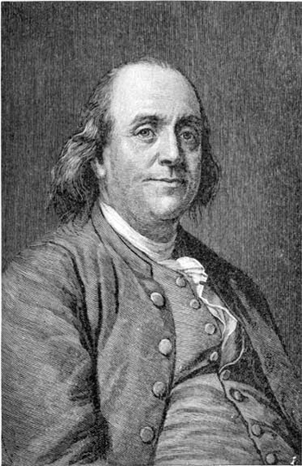 Benjamin Franklin
Of the major historical figures from around the time of the American Revolution, Benjamin Franklin, though burly and bald, is the enduring rock star. None of his peers accomplished so much in so many different endeavors: science and technology, printing and publishing; diplomacy, education, and public service; and an endless stream of writing – to educate his fellow citizens, promote personal growth and worldly success, and promulgate the political and social values he held most dear. He was also one of the great self-promoters in the American cultural tradition, one of the first true masters of the modern art of PR.

1. How is “The Way to Wealth” and auto-American-biography (consult blue glossary handout)? What is Franklin’s idea of an ideal American (similar to or different from our earlier American writers), and how do we see this very self-consciously crafted?

2. Many critics have commented on Franklin’s use of satire and irony in his writings. Do you find any evidence of satire of irony in “The Way to Wealth”?

3. In contrast to the religious perspective of the Puritans, how does “The Way to Wealth” reflect Franklin’s and the society’s belief in Deism? (See blue glossary handout)

4. Analyze some of the symbols that might give a richer understanding of the themes and tone: The coat, the setting outside the market, the character names, etc.

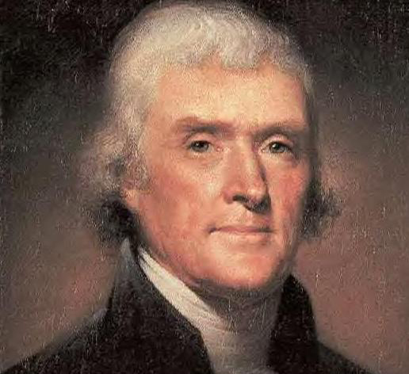Thomas Jefferson
Jefferson compares to Franklin and Edwards in being an intellectual adventurer, interested in many fields of study and willing to trust reason, direct observation, and logic, rather than prevailing opinions and conventions. He was a slaveholder who drafted one of the fundamental affirmations of human rights, the Declaration of Independence; he was an aristocrat who took enormous risks with his social standing and personal fortune; and he was a key figure in the theory and practice of American higher education, helping to begin a revolution there which continues to this day. The Norton Anthology selections give us a sense of Jefferson's range and contradictions.

1.How does the Declaration of Independence reflect the values and philosophy of the Age of Reason, Neo-classicism, and the Age of Enlightenment?

2. Examine the sheer sound and beauty of the language like the use of parallelism, alliteration, and assonance. How does that effect the tone and the readers’ reception?

3. Jefferson's Autobiography offers us two versions of the Declaration of Independence--the draft that Jefferson presented to the Continental Congress, and the final version that was published and sent to King George III. We have, therefore, a wonderful opportunity to see a founding document undergo substantial revision and to speculate on the political and moral motives and rhetorical tastes which caused these changes to be made. In the draft, look at the long deleted paragraph beginning "He has waged cruel war against human nature itself" and at the deleted excerpt toward the end of the document, beginning "At this very time too, they are permitting their chief magistrate . . ." Why exclude these passages? Who is the implicit audience? Are there differences between the rhetoric of these deleted passages and the general tone and style of the final document?

