Ice Breaker 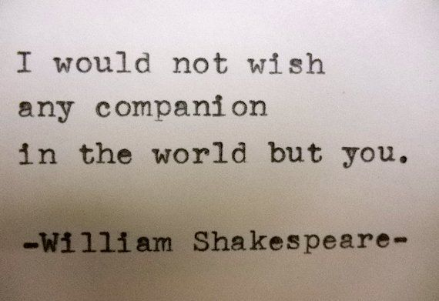

Objectives:
1. Get to know each other.
2. Learn through collaboration.
3. Realize that we have many commonalities, much like we can find the commonalities with the author we will read this quarter.
4. Have fun and win prizes!

Directions: Walk around the room and talk to as many people as you can in order to find another person who has a similarity with you. Write down the person’s name for each answer. You may only use a person’s name once, so be selective. The winner is the first person to finish.

Find someone who…… Name

- has the same number of siblings as you. ________________________

- has read at least one similar Shakespeare play as you._________________________

- has the same birthday month as you.___________________________

- has visited England. _________________

- knows who was Queen when Shakespeare lived.______________________

- has seen a live Shakespeare performance. _____________________________

- has had the same instructor as you in another quarter. ______________________

- loves the same food as you. ____________________

- can recite one line of Shakespeare. ________________________________

- is wearing the same colors today as you.________________________

- has seen the same movie as you in the last 3 months. _____________

- knows who Puck from A Midsummer Night’s Dream is._______________

- knows one modern adaptation of a Shakespeare play. ___________________

