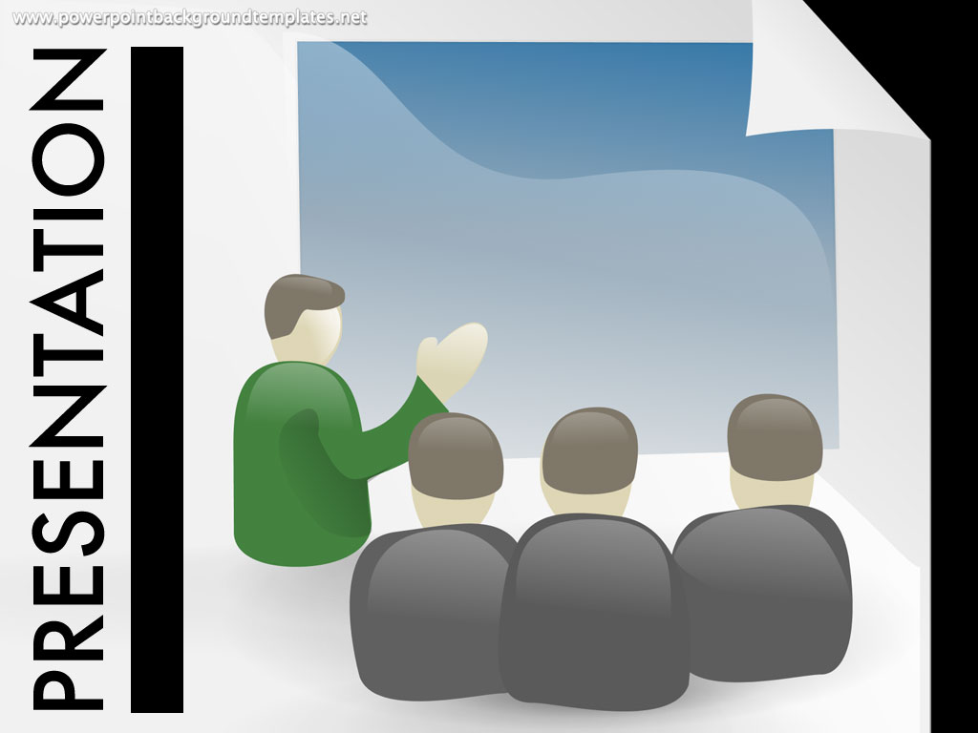 PRESENTATIONS
Each group is responsible for giving a 20-30 minute presentation on one period/movement of early American literature, which we will discuss for that week.
For example, if your topic is “Discovery and Conquest” on week 2, you can present on the overall landscape of countries discovering the “new world.” What is the history and philosophy around the new world discoveries? How can we understand the literature we are reading that week better from a cultural context? Who are the authors we are reading? Tell us about their lives and how they are connected to the texts we are reading. Start with the information in the introductory sections of the Norton Anthology but then move beyond that information with more outside research that presents in depth knowledge, visuals, and insights.
This assignment is worth 10% of your grade, and each student will receive a separate grade. To receive a successful grade, you must:

- Be prepared for the beginning of the day assigned
- Verbally present knowledge of the topic
- Connect ideas to the texts we are readings as much as possible.
- Be creative! Bring visuals, props, costumes, video clips, interactive games, prizes – make it interesting for the audience!
- Submit a one paragraph, typed summary of your individual contributions and how your knowledge of American Literature has expanded.
***Dates are subject to change. Please be flexible.

Topic Names
1) Discovery and Conquest 1.____Giana Lozano___ 2. ___Anthony Lazrovich__ 3. _Abriana Rodriguez____
10/5 4. __Luciano Ocampo______ 5. ___Andrew Kaila____

2) Settlement and Religion 1. _Vanessa Zimmerman_ 2. ___Melissa Young__3. ___Anthony Pham
(Puritans and Pilgrims) 4.______Osiris Galera___ 5. _Dane Howard________
10/10

3) Revolutionary Writings 1.__Devon Johnson___ 2.___Haris Alic________3. _Andy Allison_______
(The Age of Reason) 4.____EJ Bernil______ 5. _Lisa Brown___________
10/17

4) The Emergence of Fiction in a New Nation 1._Pocholo Carsi-Cruz__ 2.Lizzie Whitfield__3._Dylan Clark_
(The American Renaissance) 4. _Cristian Cortez_ 5. ___Emma Farry___
10/24

5) The American Romantic Movement 1.__Chandler Fasoletti__ 2. __Parker Hardin_____ 3. __Haroon Hayat___
Part I – Focus on Hawthorne 4.Jelsie James_5. _Andrea Jimenez___
11/7

6) The American Romantic Movement 1.__Olivia Kristianto____ 2. Daisy Kuang___3. _Andrew Pang___
Part II – Focus on Melville 4.__Hazel Liang_ 5.__Aaron Angeles__ 6. Jonathan Valle
11/16
7) Gothic Undercurrents 1.___Dessire Valenzuela____ 2.__Hannah Park_______3. _Amanda Long______
11/21 4._Shaheer Masud__5. _Danielle Mendoza__6. Justin Wong

8) Transcendentalism 1. _Makayla Morrow_____2. __Angela Obasohan__ 3.__David Ren__
11/28 4.__Neda Sarrami_ 5. __Hitomi Sato_ 6. Demi Yang

9) Slavery and Freedom 1.Yana Schaefer___2. ___3. Christina Sullivan___
12/5 4.___Joanne Tamayo_ 5. ___Raj Thiara____6. Veronica Torres

Elit 48A Presentation: Checklist of Points

Name: _______________
Topic: _______________

- Knowledge of Topic : (__________________ out of 25 points)

- Clarity and Creativity: (____________________ out of 25 points)

- Connection to Texts:(__________out of 25 points)

- Written Summary: (______________ out of 25 points)

Total: _______________ out of 100 points

