Gothicism - Background
Americans saw many reasons to be optimistic in the second quarter of the nineteenth century. Philosophically, much of the nation had abandoned the bleak, deterministic theology of Calvin and had embraced either the Enlightenment faith in the power of human reason or a more gentle Protestant faith in a generous and forgiving God, or both. The election of Andrew Jackson in 1828 proved that a self-made man could rise from humble origins to the presidency. Requirements that voters own land were being relaxed or eliminated, so that democracy became a more achievable ideal. Spurred by a wide-spread belief in "Manifest Destiny," the young nation was expanding rapidly, growing well into the Midwest and eventually reaching the Pacific Ocean by the 1840s, gathering momentum and resources along the way. Industry became a powerful economic force, and cities began to bulge with immigrants eager for work. Reform and improvement (of daily life and labor by technology, and of social conditions by progressive activists) were spreading. And in the world of letters, writers like Ralph Waldo Emerson and Henry David Thoreau were arguing that Americans were in a perfect situation to cast off the fetters of European prejudice and habit and create a culture full of self-determined, empowered, and enlightened beings.

But if this picture represents one truth about nineteenth-century America, there are others as well. Almost 15 percent of the population was legally considered property (there were about 900,000 slaves in 1800 and about 3,200,000 by 1850). Only white, male property owners could vote. Women were largely confined to the home and certainly not expected to rise to positions of social authority. Native Americans were losing most of the power‹--and virtually all of the land--that they once held. How could all of these conditions exist, many asked, in the world's one modern nation created with the explicit purpose of establishing freedom and equality for all? In addition, rapid change was causing anxiety about the future: Where was America heading? How could it both grow exponentially and retain its unity and coherence? What if it lost its agricultural self-reliance and became beholden to the whims of European trade? Were the millions of immigrants good for the country, or did they bring dangerous and contagious influences? What were the human costs of city life and urban labor conditions? Was the Mexican War justified, or was it only a base attempt to grab more land and resources for European Americans?

It is this spirit of anxiety, fear, and even despair that writers in the gothic mode tap into. Edgar Allen Poe (as well as Hawthorne, Melville and others) explored the "dark side" of nineteenth-century America as he reveals the horror that lurks inside mankind. Prominent features of Gothic fiction include terror (both psychological and physical), mystery, the supernatural, ghosts, haunted houses and Gothic architecture, darkness, death, decay, doubles, madness, secrets, and hereditary curses.

Poe urges us to ask: What power, if any, rules us? How much are we in control of ourselves? How well do we even know ourselves? To what extent can we ever be sure of anything?

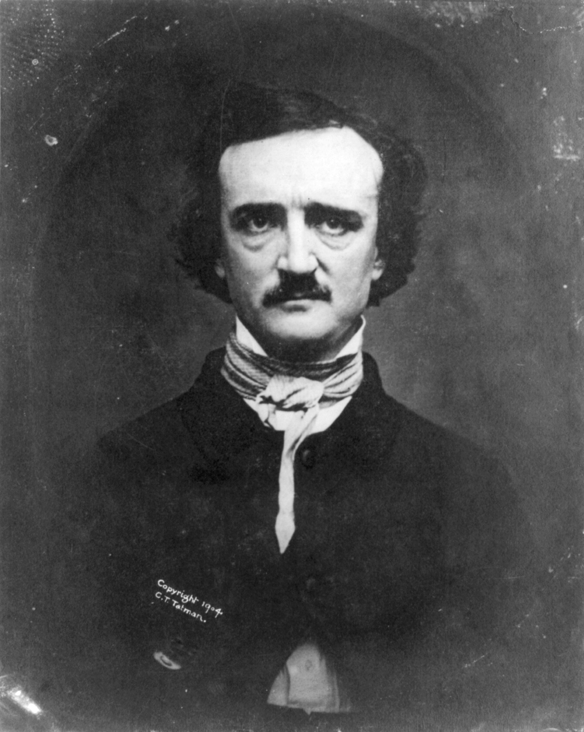Edgar Allan Poe Discussion Questions

- Explore the settings of “The Raven,” “The Tell-Tale Heart,” and “The Black Cat”? What do they all have in common and how is the setting reflective of the themes?

- Examine the narrators’ obsession with proving that he is not mad. How do the narrator explain and defend their inner landscape? What is your definition of madness and do these narrators fall under this category?

- Analyze the interconnection between opposing binaries in Poe’s works (love and hate, rationality and madness, appearance and reality, etc.)

- Point out some areas in which we have an unreliable narrator. What is the effect of having a narrator that may not be able to convey the “truth”?

- How does our thinking about Poe’s art alter if we know that Poe famously relished put-ons and practical jokes? How does comedy and horror, deadly seriousness and put-ons, mingle in popular gothic entertainments, with their habit of becoming reflexive and self-satirizing? Is there an element of the absurd about these works and is that absurdity possibly intentional?

