http://www.cloudnet.com/~renfest/end_of_raven.htm

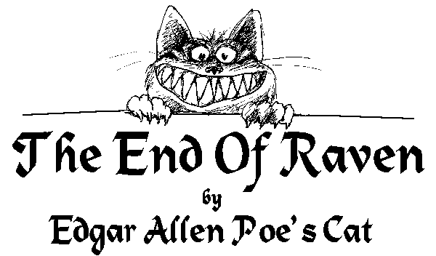
On a night quite unenchanting, when the rain was downward slanting,
I awakened to the ranting of the man I catch mice for.
Tipsy and a bit unshaven, in a tone I found quite craven,
Poe was talking to a Raven perched above the chamber door.
"Raven's very tasty," thought I, as I tiptoed o'er the floor,
"There is nothing I like more."
Soft upon the rug I treaded, calm and careful as I headed
Towards his roost atop that dreaded bust of Pallas I deplore.
While the bard and birdie chattered, I made sure that nothing clattered,
Creaked, or snapped, or fell, or shattered, as I crossed the corridor;
For his house is crammed with trinkets, curios and weird decor -
Bric-a-brac and junk galore.
Still the Raven never fluttered, standing stock-still as he uttered,
In a voice that shrieked and sputtered, his two cents worth -
"Nevermore."
While this dirge the birdbrain kept up, oh, so silently I crept up,
Then I crouched and quickly leapt up, pouncing on the feather bore.
Soon he was a heap of plumage, and a little blood and gore -
Only this and not much more.
Then my pickled poet cried out, "Pussycat, it's time I dried out!"
Never sat I in my hideout talking to a bird before;
How I've wallowed in self-pity, while my gallant, valiant kitty.
Put an end to that damned ditty - then I heard him start to snore.
Back atop the door I clambered, eyed that statue I abhor,
Jumped - and smashed it on the floor.

