Religion and Settlement

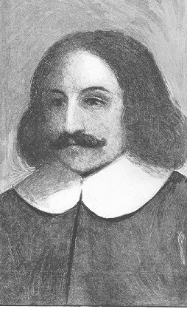William Bradford
Bradford's “Of Plymouth Plantation” (1630-50) is a long and painstaking account of the small settlement at Plymouth and the much larger colonization at Massachusetts Bay ten years later. But Bradford's history is no chronicle, not a mere sequence of "and then, and then" observations and remembrances. He thinks of these events as having a shape and a great overriding purpose.

1. Can you describe the shape and purpose that Bradford sees in the events of Plymouth and Massachusetts Bay? At what moments in his account do you see Bradford taking pains to find and explain a reason, and a direction, for various events between 1620 and 1640?

2. In seventeenth-century Puritan thought, prosperity was a mixed blessing, even a paradox. If the colony prospered, and if individuals within the congregations fared well materially, such good fortune could signify righteousness and divine favor; but these colonists took seriously the warnings in the Gospels about the near impossibility of rich people entering Heaven. Bradford sounds elegiac in his account (Book II, Chapter XXII) of the colony growing prosperous and dispersing. The colony has succeeded and is spreading inland--so how can we account for Bradford's melancholy mood?

Anne Bradstreet
An encounter with Bradstreet's poems can be a breakthrough moment if you are reading chronologically through the Norton Anthology of American Literature for she is one of the very first American artists who seems complex, complete, and fully human in the modern sense. As a way of getting acquainted, you might want to look for at least two voices, two sides of one personality speaking in her poems: there is Mistress Bradstreet the devout Puritan, leading parishioner and well-known wife of a colony official; and there is Anne, mother, lover, grandmother, who feels the full range of joy and pride and grief and who struggles to reconcile these powerful perceptions and feelings with the severe theology which pervades her community and her faith.

3.If you are looking for "Anne," you might begin with “The Author to Her Book”, which evidently was written as the epigraph to the second edition of her collection of poems. Given that Bradstreet is a strict Puritan writing in 1666, in the wake of enormous sectarian turmoil in the English-speaking world, is there anything odd or dangerous about this metaphor of her book as the "ill-formed offspring" of Bradstreet's "feeble brain"? How does it contrast with the proprieties of her city and her time?

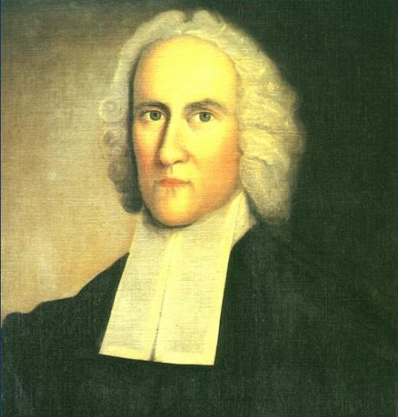Jonathan Edwards
“Sinners in the Hands of an Angry God” shows Edwards responding to an important change in Euro-American intellectual culture. The "Age of Reason" has come to America from England and the Continent, and New England Calvinists must respond to it and speak its language.

4. What are the main ways that Edwards responds to the Age of Reason and how can we see the last ditch effort of the strong hold of Puritanism in the form of the Great Awakening reverberating throughout American attitudes for generations to come?

Connections
5. On Monday, we made of list of American Ideals as suggested by Columbus and John Smith (radical individualsm, distrust and disdain of upper class and money, responsibility and hard work, capitalistic opportunity, self-agrandizing, bravery and adventure, dominance and exploitation of land, etc.) How do Bradford’s, Bradstreet’s, and Edward’s writings support or contradict these American Ideals and what new ideals do we see emerging?

