Shakespeare Biography
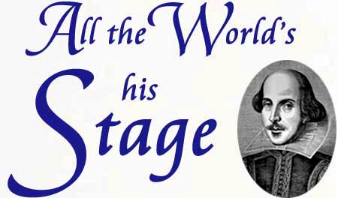

- Who ruled England when Shakespeare was alive?

- Where and when was Shakespeare born?

- What was Shakespeare’s education?

- Who does Shakespeare marry? Any children?

- Who is the Earl of Southampton?

- What themes are in the sonnets?

- What is the quality of Shakespeare’s marriage?

- What reasons did the theaters sometimes close?

- What themes resonate throughout the plays?

10.Describe the Globe Theater.

11.How successful does Shakespeare become?

12.How does Shakespeare’s career end?

13. How does he die?

