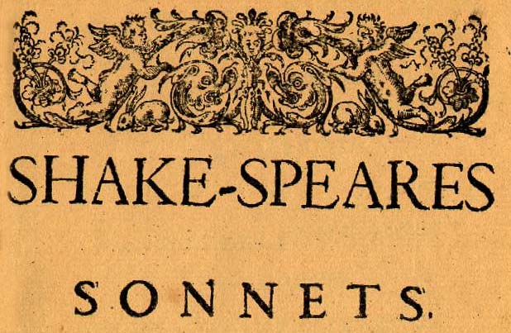
Analyzing a Sonnet

18
Shall I compare thee to a summer’s day?
Thou art more lovely and more temperate.
Rough winds do shake the darling buds of May,
And summer’s lease hath all too short a date.

Sometime too hot the eye of heaven shines,
And often is his gold complexion dimmed;
And every fair from fair sometimes declines,
By chance, or nature’s changing course, untrimmed;

But thy eternal summer shall not fade,
Nor lose possession of that fair thou ow’st,
Nor shall Death brag thou wand’rest in his shade,
When in eternal lines to time thou grow’st.

So long as men can breathe or eyes can see,
So long lives this, and this gives life to thee.

4 lease = allotted time 4 date = duration 7 fair from fair = beautiful thing from beauty 8 untrimmed = ornament taken off 10 thou ow’st = you possess

130
My mistress' eyes are nothing like the sun;
Coral is far more red, than her lips red:
If snow be white, why then her breasts are dun;
If hairs be wires, black wires grow on her head.

I have seen roses damask'd, red and white,
But no such roses see I in her cheeks;
And in some perfumes is there more delight
Than in the breath that from my mistress reeks.

I love to hear her speak, yet well I know
That music hath a far more pleasing sound:
I grant I never saw a goddess go,--
My mistress, when she walks, treads on the ground:

And yet by heaven, I think my love as rare,
As any she belied with false compare.

5 damasked = mingled red and white 8 reeks = emanates 11 go = walk 14 she = woman 14 compare = comparison

Critical Approaches to Literature and Criticism

- Reader-Response - Focuses on the reader (or "audience") and his or her experience of a literary work, in contrast to other schools and theories that focus attention primarily on the author or the content and form of the work.

- Feminist Criticism—Focuses on female representation in literature, paying attention to female points of view, concerns, and values. Three underlying assumptions in this approach are: Western Society is pervasively patriarchal, male centered and controlled, and is organized in such a way as to subordinate women; the concept of gender is socially constructed, not biologically determined; and that patriarchal ideology pervades those writings which have been considered “great works of literature.”

- Queer Theory: Combined area of gay and lesbian studies and criticism, including studies of variations in biological sex, gender identity, and sexual desires. Emphasis on dismantling the key binary oppositions of Western culture: male/ female, heterosexual/ homosexual, etc. by which the first category is assigned privilege, power, and centrality, while the second is derogated, subordinated, and marginalized.

- New Historical Criticism—Focuses on examining a text primarily in relation to the historical and cultural conditions of its production, and also of its later critical interpretations. Cultural materialism, a mode of NHC, argues that whatever the “textuality” of history, a culture and its literary products are always conditioned by the real material forces and relations of production in their historical era.

- Psychological Criticism—Focuses on a work of literature primarily as an expression, in fictional form, of the state of mind and the structure of personality of the individual author. In other words, a literary text is related to its author’s mental and emotional traits. Furthest extension is Psychoanalytic Criticism, emphasis on phallic symbols, wombs, breasts, etc. Theorists include Lacan and Klein.

- New Criticism – The proper concern of literary criticism is not with the external circumstances or effects or historical position of a work, but with a detailed consideration of the work itself as an independent entity. Emphasis on “the words on the page.” Study of poetry focuses on the “autonomy of the work as existing for its own sake,” analysis of words, figures of speech, and symbols. Distinctive procedure is close reading and attention to recurrent images; these critics delight in “tension,” “irony,” and “paradox.” (Similar to Formalism or Neo-Aristotelian)

- Marxist Criticism—Focuses on how literary works are products of the economic and ideological determinants specific to that era. Critics examine the relationship of a literary product to the actual economic and social reality of its time and place (Class stratification, class relations, and dominant ideology).

- Deconstruction—Focuses on the practice of reading a text in order to “subvert” or “undermine” the assumption that the text can be interpreted coherently to have a universal determinate meaning. Typically, deconstructive readings closely examine the conflicting forces/meanings within the text in order to show that the text has an indefinite array of possible readings/significations.

- Archetypal/Mythic Criticism—Focuses on recurrent narrative designs, patterns of action, character types, or images which are said to be identifiable in a wide variety of literary works, myths, dreams, and even ritualized modes of behavior. Critics tend to emphasize the mythical patterns in literature, such as the death-rebirth theme and journey of the hero.

For more on Literary Theory, check out the Purdue Online Writing Lab: http://owl.english.purdue.edu/owl/resource/722/1/

