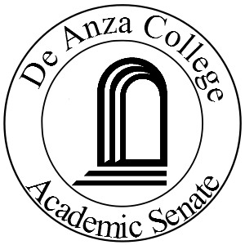The Newsletter
of the De Anza Academic Senate
June, 2014 Page One

President’s Message
Mayra Cruz

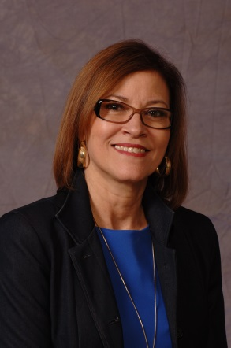
“ I have learned that people will forget what you said, people will forget what you did, but people will never forget how you made them feel.” Maya Angelou

Our students at De Anza will never forget how we made them feel.



Thank you to each one of the Senators involved with our work this 2013-14

See “President's Message”
page two, column one

Vice President’s Message
Randy Bryant

Wow, can you believe that the school year is almost over? This was one of the fastest years for me so far. I hope you had a great year! This was the year we completed our comprehensive program review (CPR). We worked to update the college mission statement. We all worked hard to increase enrollment to help stabilize our budget. We also made progress on our equity commitment. It was great to see so many doing so much to help our students.
The CPR‘s have all been completed and the Deans have presented them to the Instructional Planning and Budget Team (IPBT). It was very evident that we all are working hard and focusing on student success. The presentations also highlighted opportunities as we continue with our equity work. Thank you to all that helped with the CPR work. Thank you to all that helped with completing the Student Learning Outcome (SLO) and Program Level Outcome (PLO) work with a special thanks to Mary Pape for guiding us throughout the process.

See “Vice”
page two, column two
President's
From Page One

academic year. Our deep appreciation to
many faculty members who have dedicated time to serve our college on campus committees, projects, and activities to support and sustain positive student
outcomes. To our classified professionals and administrative team, thank you for all you do. To our students, our many thanks for continuing to be our inspiration!
This year, we have moved from tired to inspired, from busy to effective. The spring is the time for rejuvenation and renewal. During the spring, we have achieved much
progress on our 13-14 focus areas.
- Supported faculty to fulfill the requirements under our Comprehensive Program Review. Thanks Randy Bryant and Mary Pape for your leadership.
- Engaged and supported Faculty and Senators in Equity Work. A special shout out to Veronica Neal for guiding and supporting the Senate Equity Subcommittee.
- Supported the implementation of the SB 1440/Student Transfer Achievement Reform Act (SB440)/Transfer Degree Work. A special thanks to our ADT (Associate Degree for Transfer) Leadership Team--- Christina Espinosa-Pieb‎, Rowena Tomaneng‎, Paul Setziol‎, Randy Bryant‎, Anu Khanna‎, Ram Subramaniam‎, Angela Caballero
- De Cordero, Kathleen Moberg‎, Renee Augenstein‎, Marisa Spatafore‎, Patricia Gibson‎, Kent Mcgee‎, and Stacey Cook

See "President's”
page three, column one

Vice
From page one

As we finish the school year and head into summer, please encourage students to sign up for summer classes. We are still facing a budget challenge dealing with enrollment. We need to increase enrollment to stabilize and improve our budget. Also, encourage students to look at the new enrollment priority requirements. When you hear people talk about students not being accepted at other colleges, remind them that (as President Murphy said) “they are already accepted here” at De Anza College.

We would like to thank all that have served on the many committees this year. They are too numerous to list here but all of them fill a need and help keep the college in position to excel. Without your dedication and involvement, the place we call De Anza College would not be what it is today. Your participation in our shared governance is a model for the state. You should be very proud that, when other colleges struggle with governance issues, they look to see how De Anza does it!
Please take a minute and thank our colleague’s that make our work here possible. Without the support of the classified professionals we could not do what we do. Thank you for another great year and putting our students first. Have a great summer and I look forward to seeing you in the fall.

President's
From Page Two

- Supported Student Success and Services Program (SB1456 Student Success Act of 2012) Work
- Under the leadership of Rene Anderson-Watkins, we have engaged in part-time issues related to the use of office space and dissemination of information including part time hiring processes. Thank you Rene!
- Participated in the college mission statement review process. A special thanks to Mallory Newell for her ongoing support and for keeping us on track.
- Formed and provided leadership to the General Education Philosophy Review committee. Special thanks to Ram Subramanian and Danielle VonMatt for their leadership and facilitation and committee members Erik Woodbury, Rene Anderson-Watkins, Randy Bryant, Lena Chang, Danielle Von Matt, Alicia De Toro, Mary Donahue, Brandon Gainer, Dawnis Guevara, Cynthia Kaufman, Margo Raff, Dan Salah, Paul Setziol, Rowena Tomaneng, Cheryl Woodward, and our student intern Tak Wah Leung
- Provided leadership to address campus printing needs. Our fierce leadership Mari Tapia and Karen Chow lead this work with Purba Fernandez, Ravjeet Singh, James Nguyen, Diane Mathios, Rene Anderson-Watkins, Randy Bryant, Paul Setziol. Thank you !

Update on Senate Equity Work
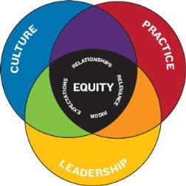
The Equity Subcommittee has involved the Senators in ongoing equity conversations. In leading for equity, the senators have discovered that this work is complex. How do we engage our Senate community in problem analysis and strategy development process? We realized that step #1 is to hold meaningful dialogue and discussion. Through scenarios and activities we have open up ourselves to explore the meaning of equity and social justice. We have begun to create shared language and have been involved in deepen trust work. We are looking forward 2014-15, a year of reflection on stories and an opportunity to establish some actions and directions.



The AcademicSenate has a primary oversight responsibility in the implementation of SB 1440/SB440. During the spring, we worked to provide directionand updates, identified roles and expectation for Department Chairs and Faculty and working to continue the development of new transfer degree in applicable a disciplines. For more information visit http://deanza.edu/aatastdegrees/


General Education Review

Under the leadership of Ram Subramaniam and Danielle Von Matt, the Steering Committee has held a series of meeting and developed a draft philosophy statement. The revised draft statement will be presented through forums to faculty and students this fall. For more information contact Ram Subramaniam subramaniamram@fhda.edu




During this year concerns around printing needs have been heard across the campus. As you know, a survey was conducted in early Winter. The survey results highlight less paper pedagogy, equity/digital divide concerns and best practices. The Printing Needs subcommittee has been working promote an ongoing dialogue regarding faculty and programs printing needs. Campus wide “B” budgets have been reviewed and budget balances will be revisit in the early fall. Division and Department faculty are encouraged to be part of the planning of the Divison “B” budget to ensure that printing needs are addressed. Ideas to on “Less Paper Pedagogy” are posted on the Senate webstie, under What’s New. http://www.deanza.edu/gov/academicsenate/ For more information, contact Karen Chow at chowkaren@fhda.edu or Mayra Cruz cruzmayra@fhda.edu

Congratulations to our 2014 Graduates!
Honor with your presence your students who are graduating.
Saturday, June 28, 2014 at 9am.

Have a great summer everyone!

_________________________________
Is there a particular topic you would like to see in The Newsletter?

Would you like to write an informative article or opinion piece for The Newsletter?

Would you like the Academic Senate and or The Newsletter staff to pursue a particular investigation and then publish findings?

See Paul Setziol or write to
setziolpaul@deanza.edu or call 8358

