

De Anza Dining Services
Educational Resources & College Operations
Program Review 2014

- Mission
De Anza Dining is a not for profit Community College-managed auxiliary service that receives no subsidy from the government. We obtain our revenues through our retail services, catering, conference clients and food vendors.
Our Culinary, Service and Managerial team have over 100 years of hospitality experience and are committed to providing a high quality and nutritious food in a safe, and friendly dining environment. We offer varied menu options, and quality services on campus to meet your needs.
Our team understands that everyone's dining preferences and needs are different which is why each meal served at every De Anza Dining location has multiple options. Furthermore, our diversity and experience enable us to offer students more flexible and varied meal options than those offered by most other community colleges.
De Anza Dining is also committed to sustaining the De Anza culture by supporting the student / student clubs and departments by providing some food and conference services at close to cost.
De Anza College Campus Center is divided into 4 mission departments.

The Campus Center Food Service annual budget is 1.4 million per year.

- To have wholesome, multicultural, nutritious food on a daily basis.
- Provide friendly, informed service personnel.
- To be available at the most important hours, to student, faculty and staff.
- Monitor to budget in a way that is financially successful.

- We monitor all leased Food Service Operations, with an estimated sales of 1.5 million annually. 15% commission is the base for the Food Service Department.

- 1 Chinese Vendor
- 1 Espresso Stands
- 1 Café
- 1 Mexican Vendor

- Flea Market

The Campus Center Directory also operates and monitors the flea market food operations; annual profit for the Food Service Department is 30K.

- Number of FTE

Dining Service has lost several employees to attrition over the last 4 years. Out of four positions one has been filled. The staffing costs have soared in this time period with benefits nearly doubling. We currently have full time classified employees. In place we hire up to 45 part time students and two open positions.

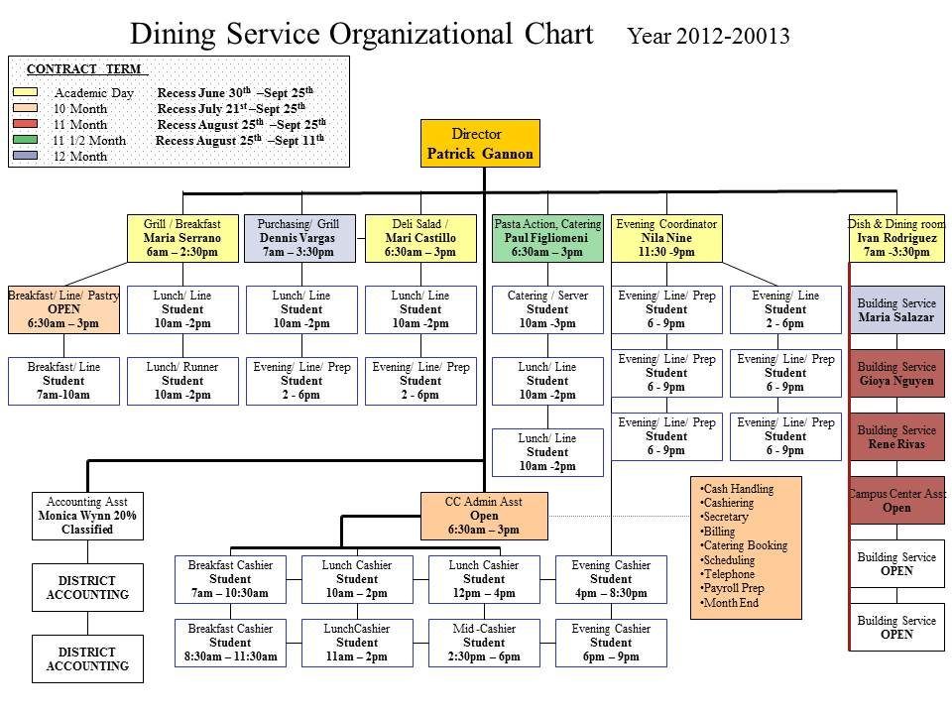

- Responsibilities

Dining Services is responsible for all food distribution at De Anza College. Dining Services operates the food court, campus catering and conference rooms in the campus center. Below is a list of responsibilities. Dining Service also manages the campus center building for maintenance, upgrades and purchases.

Food Court
The food court consists of eight stations with the concept of cooking to order or “”Just In Time Cookery”
- Action Pasta Station
The action pasta station consists of a low budget and high budget pasta. Both pastas are made to order and are at the level of any high class restaurant. The identical philosophy and fundamentals of cooker are used; the only difference is the sit down restaurant.
- Italian Foods/ Pasta & Comfort
Two types of lasagna are served daily including garlic bread. We have a selection of three pizzas daily; cheese and pepperoni don’t change, however our specialty changes daily. The grilled cheese panini and cheese and bacon are favorites as are our comfort stations during the winter with specials such as Braised Lamb Shank in Cabernet, Meat loaf, Risotto and the like…

- Grill Station
Our grill station, our most grueling because of the heat and pace, serves a variety of burgers sausages not forgetting curly fries, onion rings and a balance of veggie burgers, Portobello burgers

4. Cold & Hot Sandwich
The addition of hot sandwiches to our repertoire enhances our extensive range of signature sandwiches and wraps. A very popular station

5. Action Tossed Salad & Organic Salad Bar
The tossed salad station is now a very popular station. Based on customer surverys we added the small salad. The small salad has become even more popular than the large salad. We get our organic produce from local sources, particulary one called Alba Farms sixty five miles south of De Anza. Alba Farms doesn’t have all of our needs most of the time so, we use a broker to source it for us. The other side of the salad bar is a regular salad bar using no organic items. Both are very popular.

6. Beverage and Grab and Go Station
We serve over 45 hot and cold beverages. We are under contract with Pepsi Cola and are limited to what choices are available. The grab and go station is home to Pre made salads, sushi and condiments. All are readily available for customer not wanting to wait for just in time cookery.
Below is a map identifying stations, full and part time staffing.

7. Rotating Weekly Menu Specials
In an effort to keep our customers interested we vary our menu items in each station by rotating specials throughout the week. There is something new everyday in our food court which helps break the monotony and keep us fresh in people’s minds. Below is a complementation of some of our specials.



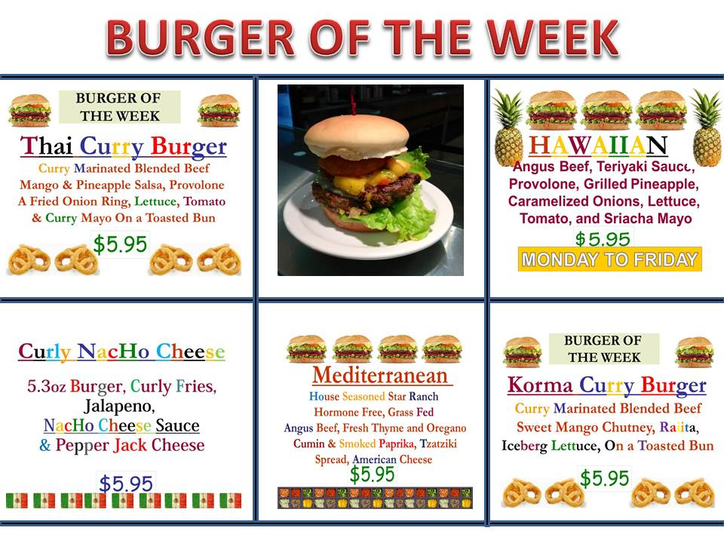

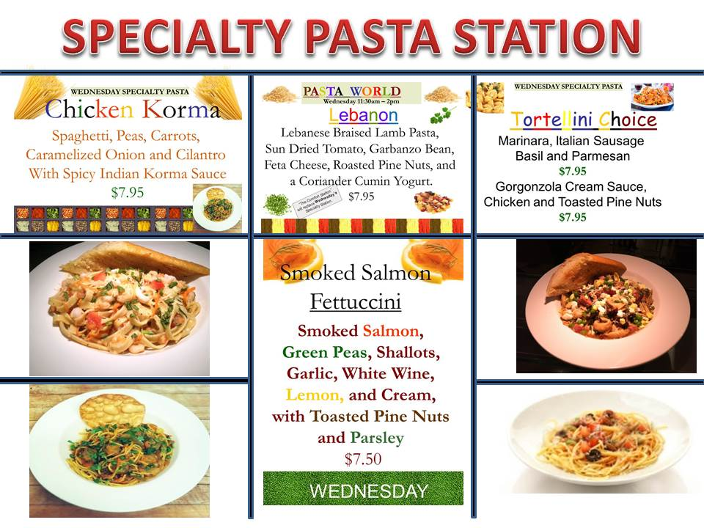



Our Latest Salad Concept

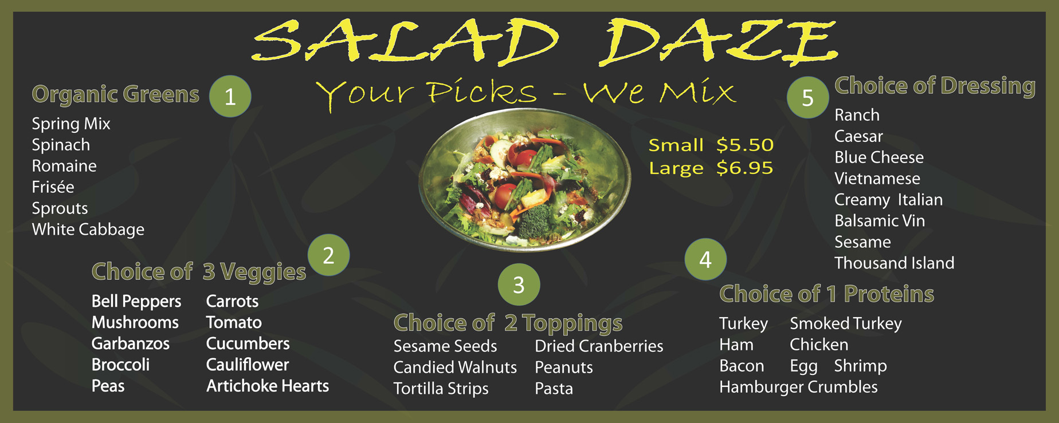

CAMPUS CENTER DINING SURVEY
JULY/AUGUST 2013
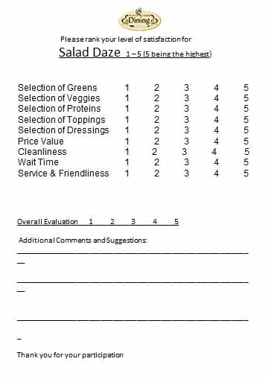

SURVEYS RETURNED: 87
OVERALL RATINGS:
5 = 37
4 = 44
3 = 3
1 = 2
NO OVERALL EVALUATION CIRCLED = 1

WRITTEN COMMENTS:
Large salads are sometimes not filled.
Too expensive.
Awesome! More vegan options?
Super nice.
Maybe because of the time that I came but a lot of ingredients were not available.
I love being able to make my own salad.
Want sliced tomatoes.
Please bring back the southwest salad (former Thursday special).
Very friendly and nice staff.
Awesome, I love it.
Much better than previous salad bar options.
Very good – like the new changes.
Love it!
Great salads!
Very friendly.
Awesome!
Great salad.
Sometimes they are too salty. Thank you.
The most delicious salad I ever ate.
Great deal!
In the past I bought salad every day. Since the changed have been made, the salad that used to cost <$3.50 now costs $6.95. As a result, I eat much fewer salads.
Consider price drop on certain days?
Keep going!Great staff and service. Fast and polite.
(UPDATED 8/7/13)

LAY OUT OF OUR FOOD COURT

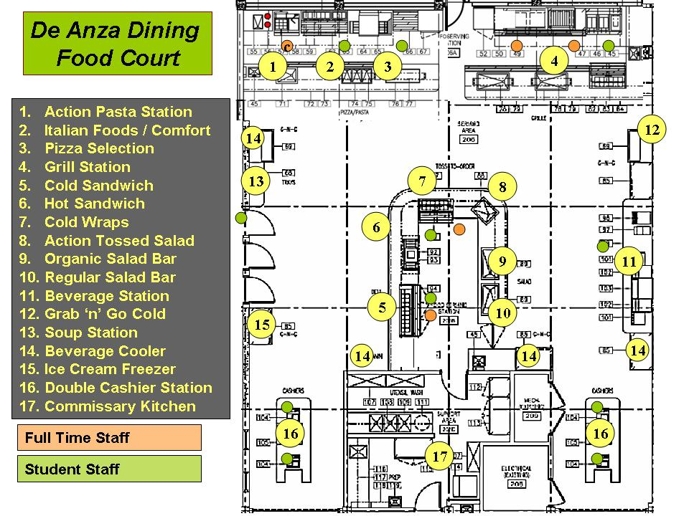

Vendors

We currently have four vendors, Una Mas, Hong Fu, Specialty Coffee and Le Cafe. All are performing very well. We also over see the vendor’s products, presentation and financials taking 15% of total sales.

Flea Market

The flea market has seen better times. The income steam as steadily decreased over the years. This is due to the economy, competition and increased parking fees from $3 to $5. The weather plays a significant role with the market including many days where it rained earning us little or no income. Provisions will need to be put in place with view of Klaus’s retirement which is still TBD.

Conference Rooms Campus Center

De Anza Dining Services takes care of all room booking at the campus center. De Anza Dining exerts enormous efforts to coordinate a fair reservation system. Coupled with the room booking catering is also preformed by the division bringing in a substantial income stream.

Building Maintenance

The upkeep of the building is monitored by the Director and his administrative assistant. Maintenance requests and entered on line to plant service, which in turn completes the tasks. Plant services bills back to the Campus Center fund for all repairs including on going preventive maintenance.

- Budget Summary

De Anza Dining Service did not make a profit in 2012/ 2013. This was the first loss in eleven years.
An eleven thousand equipment bill was posted in this year instead of last year. Rising student labor cost heavily contributed to the final negative number. Food cost saved the day by dropping more than 4% over the previous year due to negotiating contracts and by joining a national purchasing program.

Year | 2009 | 2010 | 2011 | 2012 | 2013
Gross Sales | $1,691,241 | $1,651,598 | $1,665,837 | $1,555,502 | $1,555,655
Food Cost | $776,000 | $820,413 | $886,337 | $736,228 | $666,691
Operating Expenses | $979,500 | $983,500 | $983,200 | $287,947 | $304,927
Salaries and Wages | $733,027 | $721,550 | $716,686 | $634,336 | $814,414
Commissions | $215,137 | $196,656 | $199,014 | $231,088 | $230,836
Net Income after Distribution | $137,000 | $40,533 | $74,953 | $115,588 | -$16,933

Accounting:

In order to fully understand how a budget is put together one needs to understand the daily operational income and expenditures. A budget comprises of many packets and sections of information both based on historic data and forecasted events. At De Anza Dining we enter sales and purchasing data daily giving us a twenty four hour dashboard of where we stand. In the past we had to wait six weeks to find out what was happening with our operation and in many cases too late to react, thus losing income. Below is a copy of what we use to document Instead of waiting six weeks to find out what is happening we get that picture daily capturing our customer count and check average.
Accounting:
By entering in every invoice it achieves two things. Most importantly, it gives the Director a chance to keep and eye on what’s being purchased identifying any major increases. Armed with this information we can confidently identify problem areas and create an action plan to make corrections.

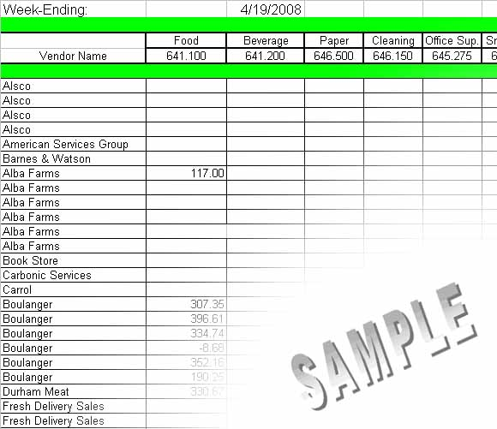

03/12/2011

- Strengths
De Anza Dining is recognized as a reputable food service operation on and off campus. De Anza Dining Service Received national recognition from the National Association of College Food Service Association winning gold and the overall award in the Loyal Horton Awards in Washington DC.
Provide budget catering to the student groups and certain struggling no funded departments. Dining service is in a constant state of innovation and reinvention.

- Weaknesses
The most biggest threat to Dining Services are rising labor cost. (See plan)
Our staff is aging with much absenteeism for medical leave.
Rising costs drive up pricing
Transportation on campus is dangerous with the current vehicle.
There’s never enough time to train the staff.
The director does not have a second in command.
Theft in the food court is still rampant
The economy hasn’t improved much.

- Trends

Positive
People are eating out more often. We are current on culinary trends from a college university and retail point of view.
We have had articles written about our innovative world risotto in Campus Hospitality.
Students don’t seem to be heavily effected by the economic down turn as it is possible that they most likely haven’t lost anything substantial. This is not to say that they won’t be affected as much retail has already closed. We have made substancial advances with the food cost by joining national purchasing chains such as HPSI. This year

We also have a facebook page
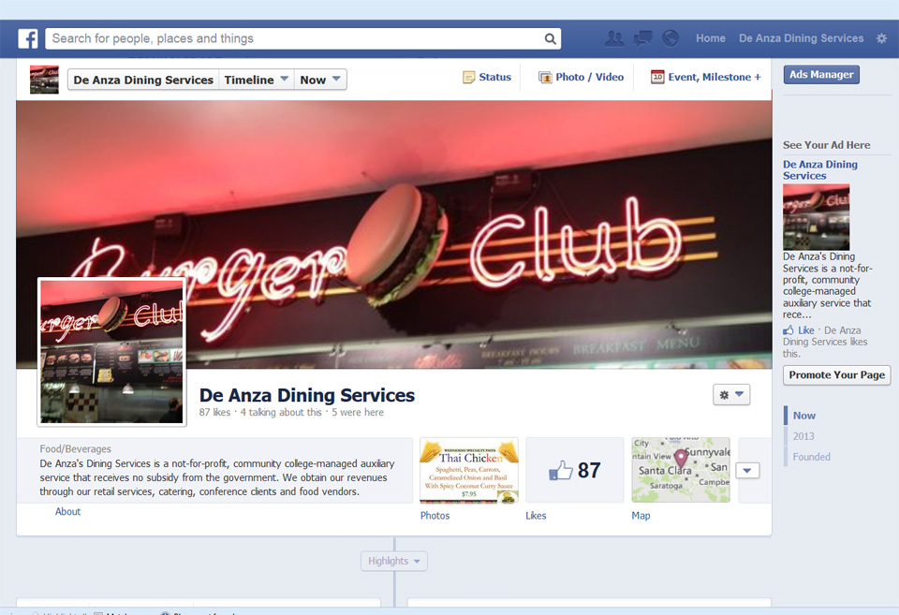

Negative
The competition outside is fierce which in turn lowers pricing to gain customer base.
Commodities are constantly rising increasing food cost beyond belief. All our tricks have been tapped out as far as saving on the cost of food. Prices are the only area that we can increase.

- Quantitative Workload Measurements

Based on last year’s numbers the food court has remained flat with less than a thousand dollars difference. We monitor daily our sales versus last year and compare check average and customer count giving us an up to date operational dashboard. Below is an example of what is documented.

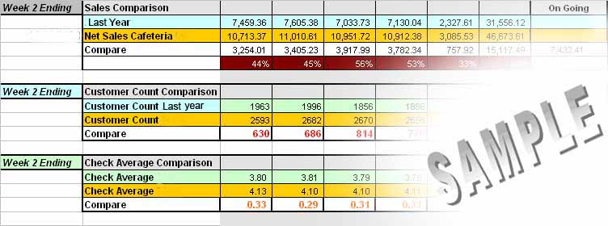

I.Qualitative Measurements

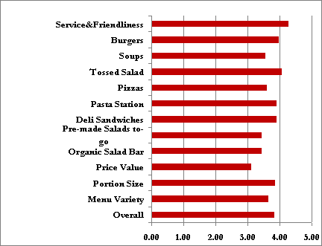
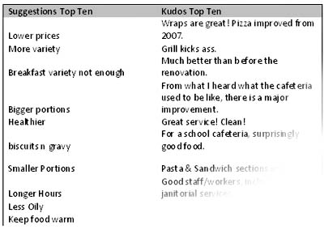
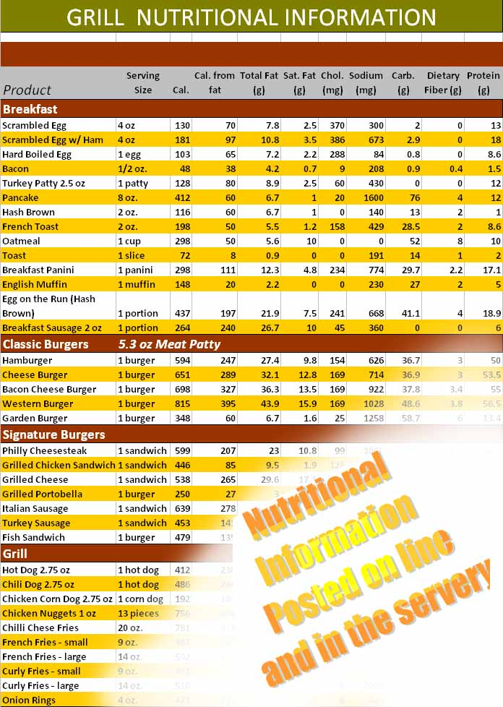
Satisfaction Survey:

Every year we compile a satisfaction survey to get a pulse on how we are doing and solicit suggestions and comment. Above is the survey from last year with some of the comments.

The suggestions are taken into consideration and changes are made to the menu when possible.

An example of multiple suggestions was to advertise our nutritional content (see attached). Small salads were requested and put on the menu. Biscuits and gravy was added to the breakfast menu.

- Planning Agenda

Our planning for next year comprises of fine turning our menus adding and deleting menu items; this is constant every year.

We are currently researching what it will take to add an Industrial Culinary Program which in turn will hopefully add a new dimension to our operation. The module might be combined with the science center’s nutritional program; however, nothing is set in stone at this stage. The first or pilot stage would be to run it as a certificate program.

- Comments

Our “Salad Daze” tossed salad station is receiving great feedback. On July 31st though August 7th we conducted a survey

Strategic Planning

- How does your program or service respond /address the College’s strategic initiatives?

De Anza Dining’s is charged with offering nutritious and affordable food to students. In turn, students who eat balanced diets should be in better mental shape and ready for academic challenges.

- Retention, keeping them on campus, more likely

It is evident from the increase of recent sales,that more and more students are staying on campus partaking in the services at the campus center. The quality and service at the food court has improved since the renovation. Dining Service offers 35 student part time positions preparing and serving food to the community.

- Which initiatives does your program or service respond to and in what ways can the response be measured or evaluated?

The 38% increase in sales over last year says that more students are using the cafeteria. Dining Services is doing its part to retain students on campus.
Dining Service offers very low pricing to the student clubs. We make no profit from the clubs. We also give those programs that have little or no funding help with their event.

Strategic Planning

- How does the work of your program or service respond to increased access, growth, retention and/or student equity?

De Anza Dining offers multiple jobs for both local and international students in the Campus Center. We offer rental space for student, faculty and community events.

- What other programs/services are you working with to accomplish your proposed goals/outcomes?

We are currently looking at doing 6 – 8 free classes open to the college and community. These classes would demonstrate the basics skills needed to produce food at home, eg.. pasta, frying etc……

What is important to understand about your program, or service and the consequences to the college if it was discontinued or reduced?

The elimination of Dining Services at the campus center would be a disaster from many angles. Primarily, the elimination of food would effectively send people off campus with no guarantee of return; classes might be easily skipped rather than face the hassle of finding parking etc….

The nucleus of the college is the campus center, hence the name, where the majority of students congregate. The food services are what draw many students to the campus center. Eliminating this would be eliminating student culture decentralize the nucleus to else where. This was clearly seen during the renovation of the campus center; students were scattered throughout the college with no real defining central area. Loss of collegial ship might equate to no grounding ties to the campus and therefore more likely to drop.

Without the food services, there would be nobody to schedule the conference rooms leaving it a free for all – major disaster. Also, the conference rooms would loose income as there would be nobody to mange them.

T’would be a sad day for all!
College Operations Administrative Unit Outcomes

Dining Services
- Students and staff will report they are able to purchase high quality food at or below cost of outside food venues.

De Anza Dining Service is charged with breaking even without the goal of making large profits from the students. Our cliental is predominately student based. Within that student base there are some who can afford more and some less. As we design our menus we use that philosophy to price items at different levels. When designing our new food court we took into account our neighboring competition, Whole Food, Panada Express, Panera, Subway…etc….. In some cases, the competition traded quality to lower pricing. Our goal was to keep the high quality and make it affordable to the students.

De Anza Dining also provides to the student clubs at 10% above cost. Our goal is to cover our cost and support the student groups.

Over the last three years our customer count has consistently risen in ratio to the college’s enrollment.

- Students and staff will report that they are able to utilize the conference rooms in the Campus Center in an equitable manner and the staff they interact with are helpful and pleasant.

Juggling the campus community can be very problematic if not handled attentively. The campus center manages the room requests for, Administrators, Faculty, Staff, Student Clubs, DASB, Foothill College, Middlefield College and outside community groups. With the help of the Campus Center Committee, a set of rules and guidelines has been set in place to help the community navigate through the process of booking a room. During this process, we steer the client in what we believe is the best manner with the ideology that their event is ours. Our job is to make them look good, by providing, AV equipment, room setups and in particularly catering.

