De Anza College Wireless Network

Wireless at Foothill-De Anza Community College District is primarily for the Students. The wireless network is divided into segments to provide different levels of service based on the intended use.

The DeAnza Guest wireless network segment located in the Learning Center and the Dining rooms at the Campus Center provides guest access to the Internet. This access is similar to what you would have at home or in a commercial Internet Cafe. The user provides an email address to gain access to the wireless network.

The DeAnza College wireless network segment provides wireless network service to those who have a relationship with the District. Anyone with a Student ID or Employee ID has the ability to use this wireless network. This segment of the wireless network is set up to provide access to additional services not available via the Guest wireless network and to provide the appropriate level service when using wireless in the classroom. You will find this wireless network available in classrooms and conference rooms.

The DeAnza Lab wireless network segment is set up for those classrooms and labs with dedicated College provided laptops. These laptops will receive the appropriate level of service to conduct the class. This wireless network segment is not available to other wireless devices.

The DeAnza Visitor wireless network segment is for visitors who are on site for a short period of time for college and district business purposes. A few Administrative Assistants throughout the District will have the privileges to create temporary visitor accounts. The Foothill Visitor wireless network will be available mainly in conference rooms.

The Educational Technology Services (ETS) web site contains documentation on how to connect to the wireless network and the wireless network deployment schedule.

http://ets.fhda.edu/

Instructions for Students

What ID and Password do students use to connect to the De Anza College wireless network?

Students will use their Student ID and PIN number to log in to the
De Anza College wireless network.

Student ID and PIN numbers are initially assigned when a student applies to the College. For existing students who have forgotten their ID or PIN number, they should contact the Admissions and Records (A&R) department located in the Student & Community Services building. A&R does not give the information out over the phone. The counter service is available for students with photo ID from 8:00 AM to 7:00 PM Monday through Thursday. A&R will also mail (USPS) students (to the address they have on record) the PIN or ID number. They do not send information via email since it lacks the appropriate security. There is the option a student can send in a request over FAX lines with a photo ID and the ID or PIN are returned via FAX. Contact A&R for more information: 408-864-5300

Connecting to the De Anza College Wireless Network:

Select the DeAnza College Wireless Network on your computer (example below uses an Apple Laptop):

Launch a Browser and the Log In Web Page should appear:
Not all browsers will bring up the log in web page.
(If Firefox doesn't work on an Apple, try Safari)
Type your Student ID in the username field and PIN number in the password field and click on Log In.

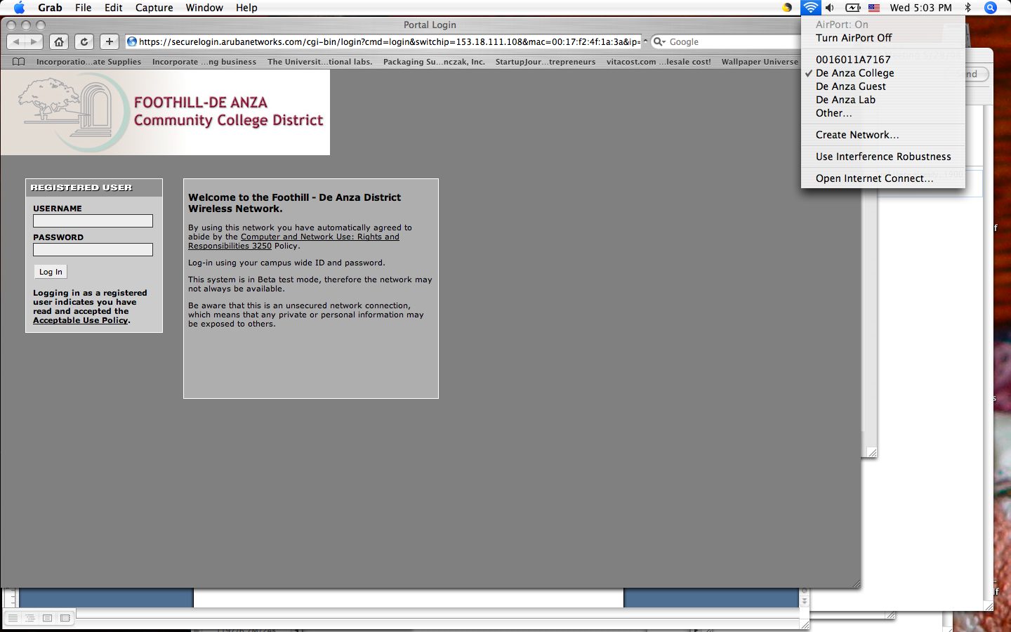

The window below should appear briefly and then your home page will appear. You are now connected to the wireless network. . (Example below shows redirection to a particular user's home page.)

