De Anza College Wireless Network

Wireless at Foothill-De Anza Community College District is mainly for the Students. The wireless network is divided into segments to provide different levels of service based on the intended use. The wireless network is not being deployed for use by employees to access secure systems such as the Student Information System (SIS), Financial or Human Resources systems.

The De Anza Guest wireless network segment located in the Library (Learning Center) and the Dining rooms at the Campus Center provides guest access to the Internet. This access is similar to what you would have at home or in a commercial Internet Cafe. The user provides an email address to gain access to the wireless network.

The De Anza College wireless network segment provides wireless network service to those who have a relationship with the District. Anyone with a Student ID or Employee ID has the ability to use this wireless network. This segment of the wireless network is set up to provide access to additional services not available via the Guest wireless network and to provide the appropriate level of service when using wireless in the classroom. You will find this wireless network available in classrooms and conference rooms.

The De Anza Lab wireless network segment is set up for those classrooms and labs with dedicated College provided laptops. These laptops will receive the appropriate level of service to conduct the class. This wireless network segment is not available to other wireless devices.

The De Anza Visitor wireless network segment is for visitors who are on site for a short period of time for college and district business purposes. A few Administrative Assistants throughout the District will have the privileges to create temporary visitor accounts. The De Anza Visitor wireless network will be available mainly in conference rooms.

The Educational Technology Services (ETS) web site contains documentation on how to connect to the wireless network and the wireless network deployment schedule: http://ets.fhda.edu/

Instructions for Employees

Employees will use their Employee ID and PIN number to log in to the
De Anza College wireless network.

The employee ID is located at the top left of the pay stub. Many months ago the PIN number was mailed to each employee through USPS. Below are instructions for obtaining your employee ID and PIN number if the pay stub and previous mailing of the PIN number are not available. These web pages are also available on the ETS web under Call Center and Accounts.

NOTE SECURITY CAUTION:
--------------------------------------
Since your ID and/or PIN number will be emailed to you (separately), you should delete the emails once you have noted or memorized the numbers. Otherwise it is unsafe to have both of these numbers residing on your computer. The combination can be easily obtain by an intruder and therefore, your personal information through this ID could be compromised.

Employee ID Lookup:
Top left corner of pay stub
-OR-
Go to: http://ets.fhda.edu/call_center/wireless
Your ID will be emailed to your District email account once you fill in each field with the correct information and press submit: Username (ugly name), Last 4 digits of SSN, Birth year.

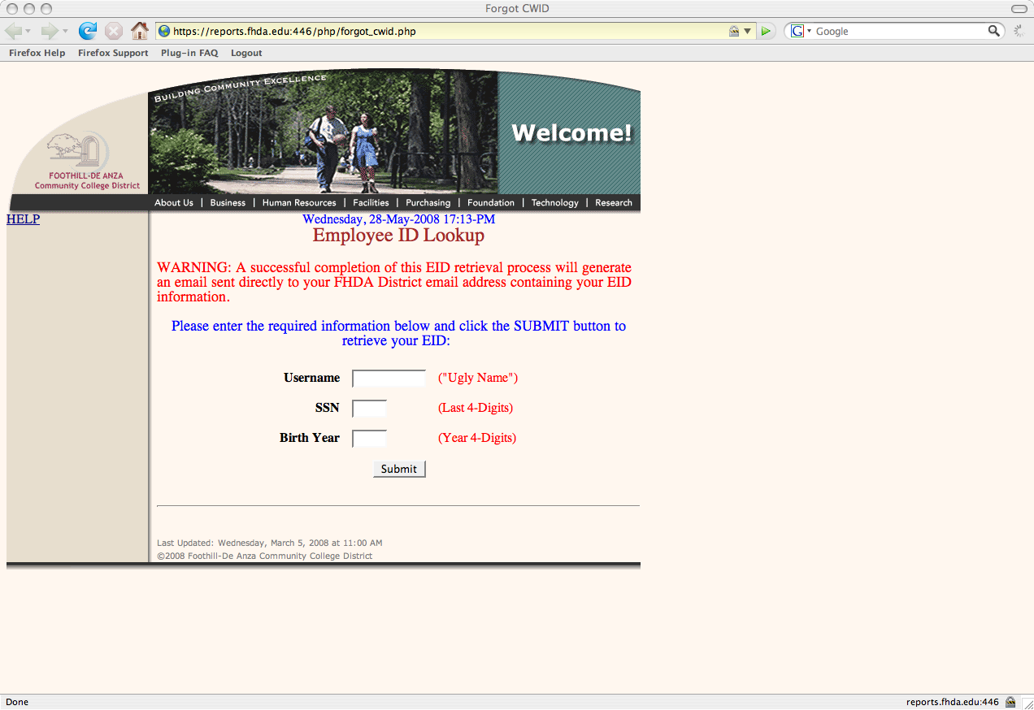

Employee PIN # Lookup:
Go to: http://ets.fhda.edu/call_center/wireless
Your PIN number will be emailed to your District email
account once you fill in each field with the correct information and press submit: Username (ugly name), Last 4 digits of SSN, Birth year.

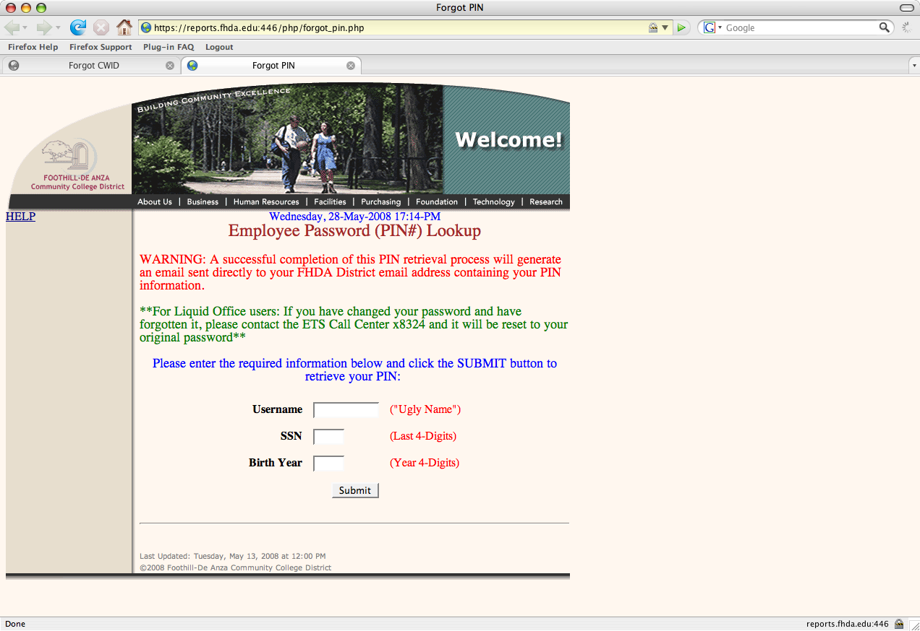

Connecting to the De Anza College Wireless Network:

Select the De Anza College Wireless Network on your computer (example below uses an Apple Laptop):

Launch a Browser and the Log In Web Page should appear:
Not all browsers will bring up the log in web page.
(If Firefox doesn't work on an Apple, try Safari)
Type your Employee ID in the username field and PIN number in the password field and click on Log In.

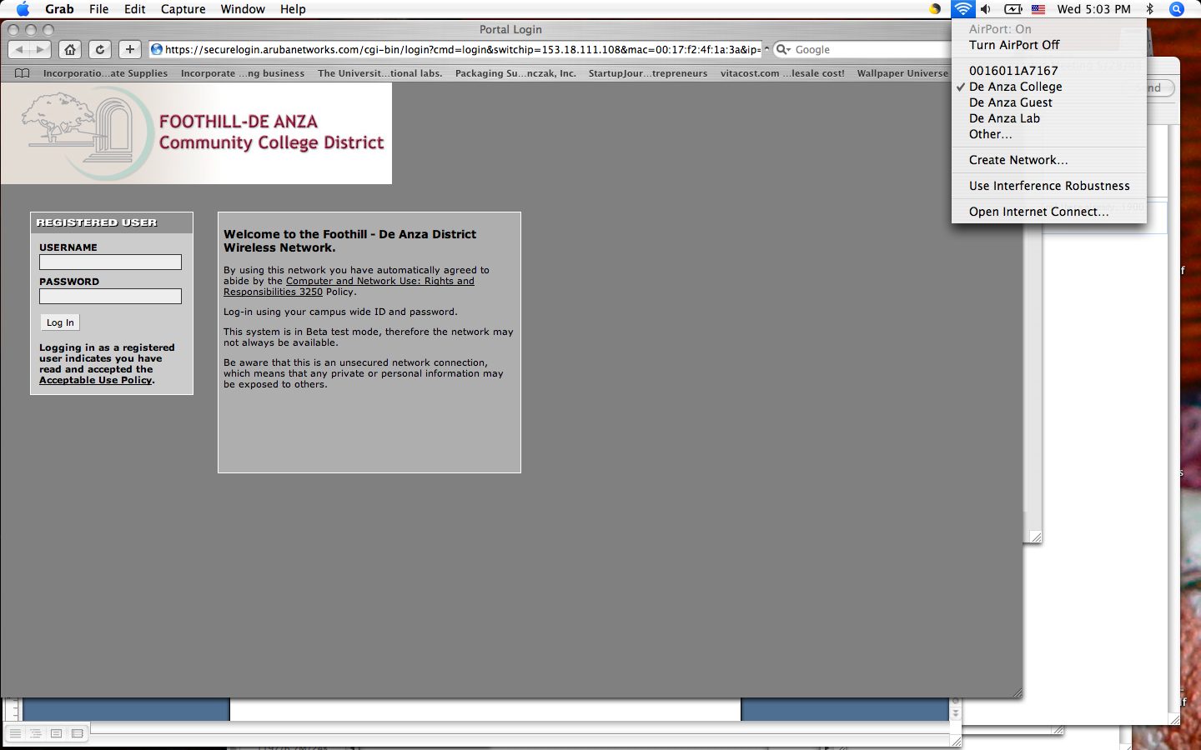

The window below should appear briefly and then your home page will appear. You are now connected to the wireless network. . (Example below shows redirection to a particular user's home page. The message you see will state your home page.)

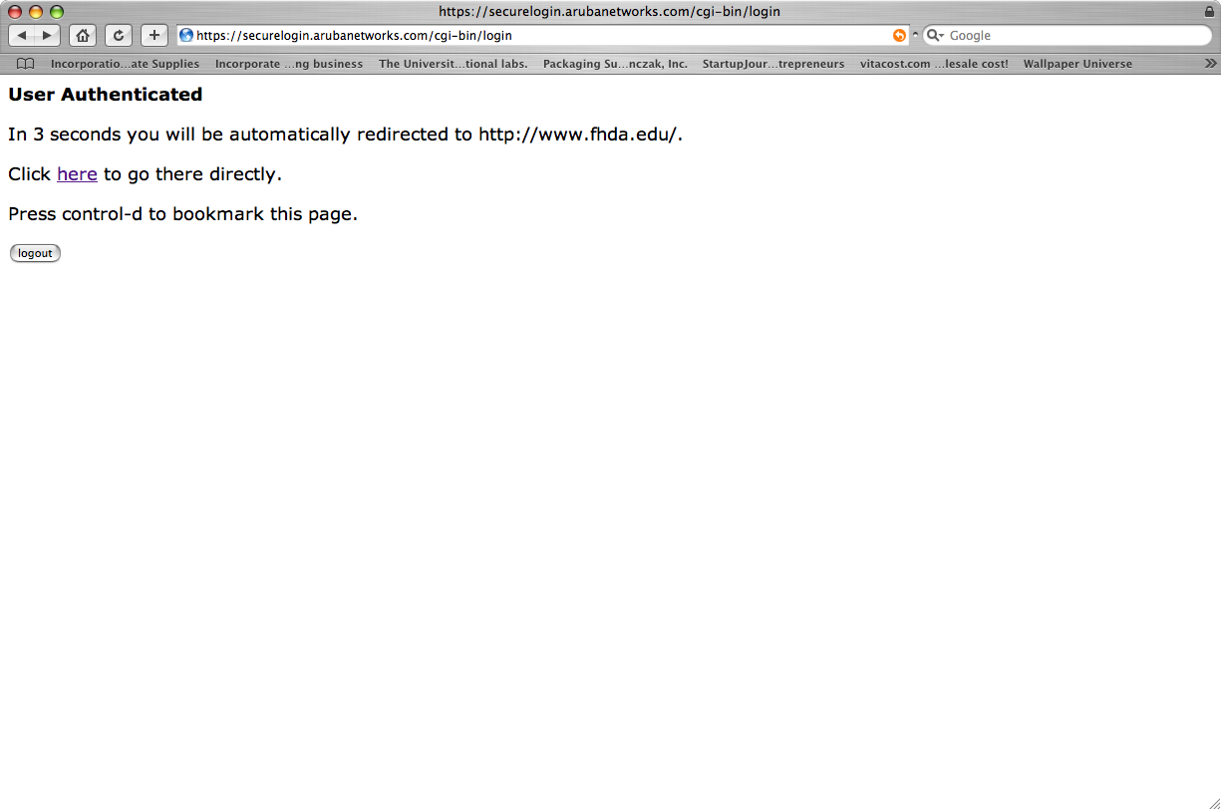

Refer to the Q&A document for more information: A separate Q&A sheet was developed. It may help if you have difficulties connecting to the wireless network.

